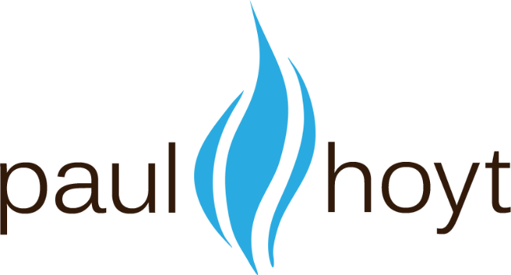

Concept Test Survey

Instructions
- Modify the template below with information and pictures of your product or service.
- Have it completed by 60 or more people in your target market and analyze the results.
- Delete this page with these instructions and the Paul Hoyt logo before sending to your market.

We Look Forward to Helping You Grow!

Concept Test Survey

Overview
XYZ company is considering investing in the development of a product / service designed to help our clients / customers with xxxxx
The Product:
The nnn product is ….
As you can see by the picture…

Our Market
We believe our market to be ….

The Questions
Please answer the following questions:
- Do you consider yourself to be in our target market? (circle one) Yes / No
- What would you consider a fair price to be for this product / service? $____________
- What price would you consider to be too high for this product? Above $____________
- What price would be so low that you think the product / service
could not reliably provide the value you would hope to receive? Lower than $____________
- If the price were fair, how likely (from 0% to 100%) would you be
to purchase the product? __________%

What features would make you more likely to pay more for the product?
____________________________________________________________________________________
____________________________________________________________________________________
____________________________________________________________________________________
____________________________________________________________________________________
What features could you do without, if they reduced the price of the product?
____________________________________________________________________________________
____________________________________________________________________________________
____________________________________________________________________________________
____________________________________________________________________________________
____________________________________________________________________________________

Thank You!
If you like, please provide your contact information and we’ll let you know when the product becomes available.
Name: _______________________________________________
Email: _______________________________________________
Phone: _______________________________________________

